MASTERS DOCUMENTATION

Application : | NGERP
Workflow : | MASTERS
Workflow Item Name : | ROLE

Description :

Role Is A Master Used To Control The User ‘s Access To The NGERP Application.

Workflow Process :

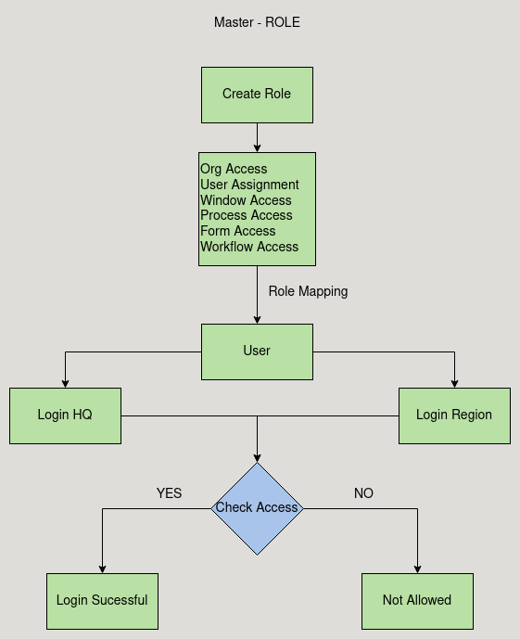

Business Rules :

- The Role Master screen is used to control the user access to the functionalities of the NGERP Application.
- There are Six Tabs In Role screen

    - Org Access
    - User Assignment
    - Window Access
    - Process Access
    - Form Access
    - Workflow Access

- Org Access:
Org Access Tab is Used to give the user access to which organisation they are able to login.

- User Assignment:
This tab is used to assign user to the role.

- Window Access:
This tab is used to give the user access to the wiindows.

- Process Access
This tab is used to give the user access to the process that they can run.

- Form Access:
This tab is used to give the user to process the form.

- Workflow Access:

- Create a Role and give access to the Organisation on which the user want to login
- Create a user and map the role created.
- Now login to region, if the user has access to region then the login will be successful
- Else the organisation drop down does not show the region or HQ

